Model coefficients for the A) AVI-based (AIC= 168.14), C) satellite-based (AIC= 160.34), E) lidar-based (AIC= 145), and G) composite (AIC= 136.11) *N*-mixture models predicting abundance of Alder Flycatcher *Empidonax alnorum*, along with predicted abundances of this species in the Kirby grid from these respective models (B,D,F,H).

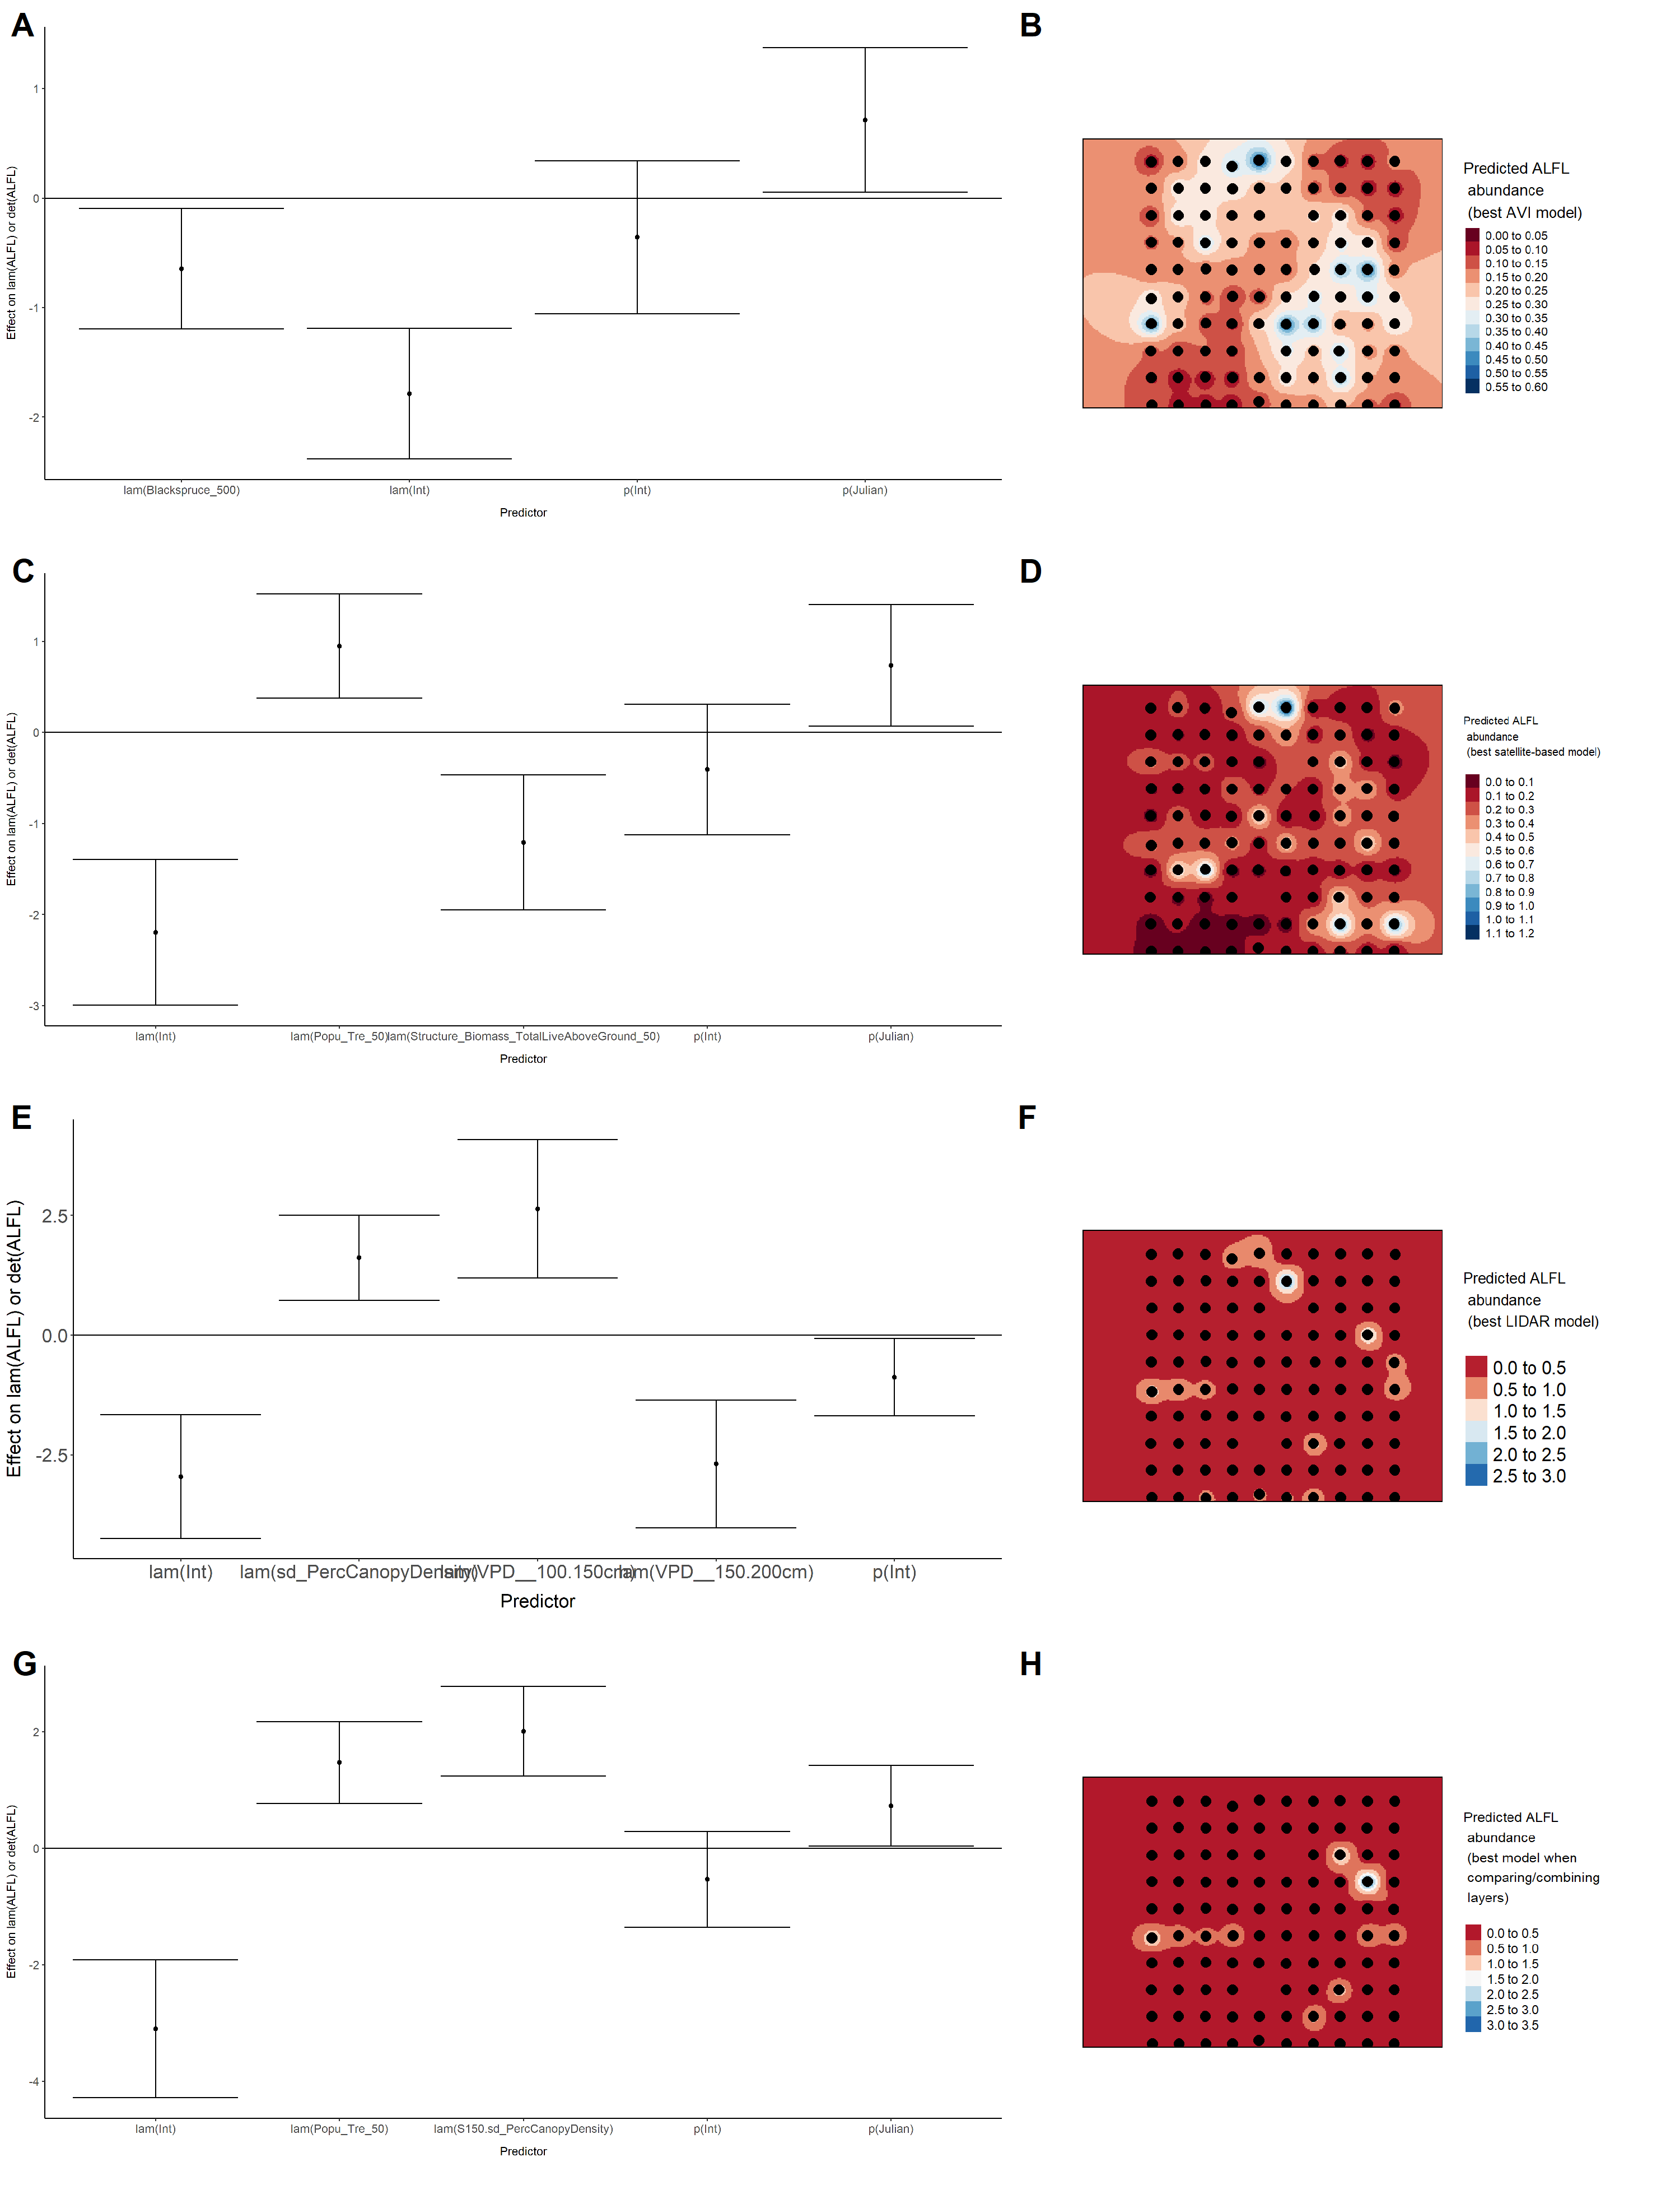

Model coefficients for the A) AVI-based (AIC= 284.87), C) satellite-based (AIC= 282.86), E) lidar-based (AIC= 285.99), and G) composite (AIC= 277.73) *N*-mixture models predicting abundance of American Robin *Turdus migratorius*, along with predicted abundances of this species in the Kirby grid from these respective models (B,D,F,H).

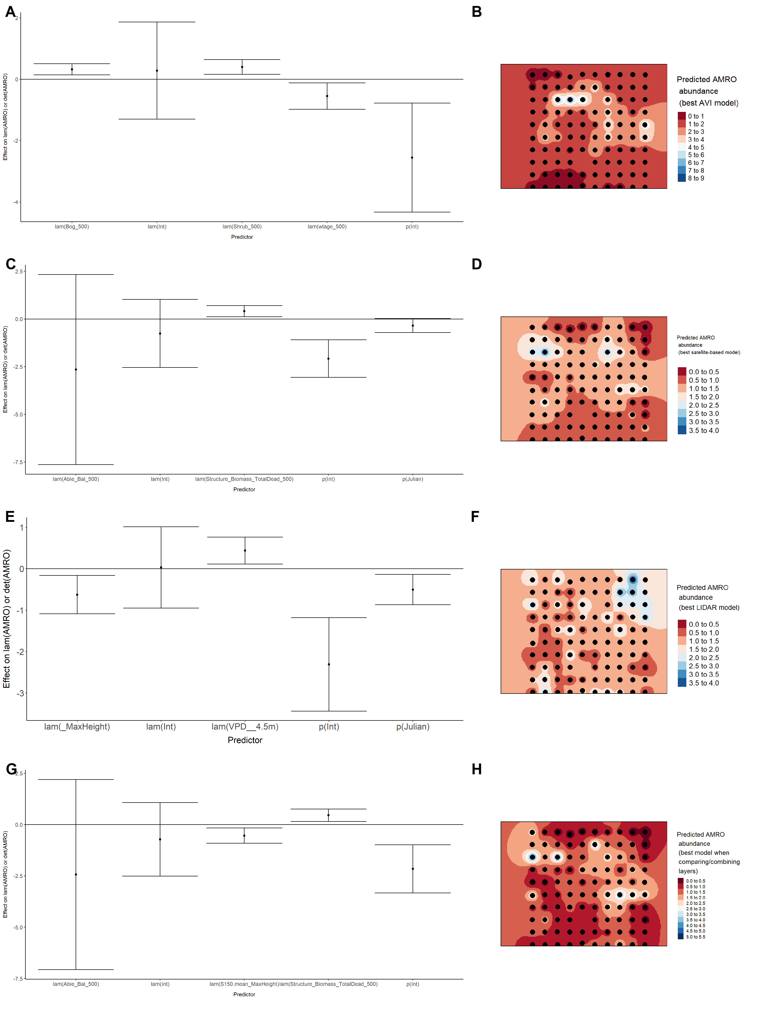

Model coefficients for the A) AVI-based (AIC= 126.92), C) satellite-based (AIC= 135.83), E) lidar-based (AIC= 127.93), and G) composite (AIC= 118.64) *N*-mixture models predicting abundance of Boreal Chickadee *Poecile hudsonicus*, along with predicted abundances of this species in the Kirby grid from these respective models (B,D,F,H).

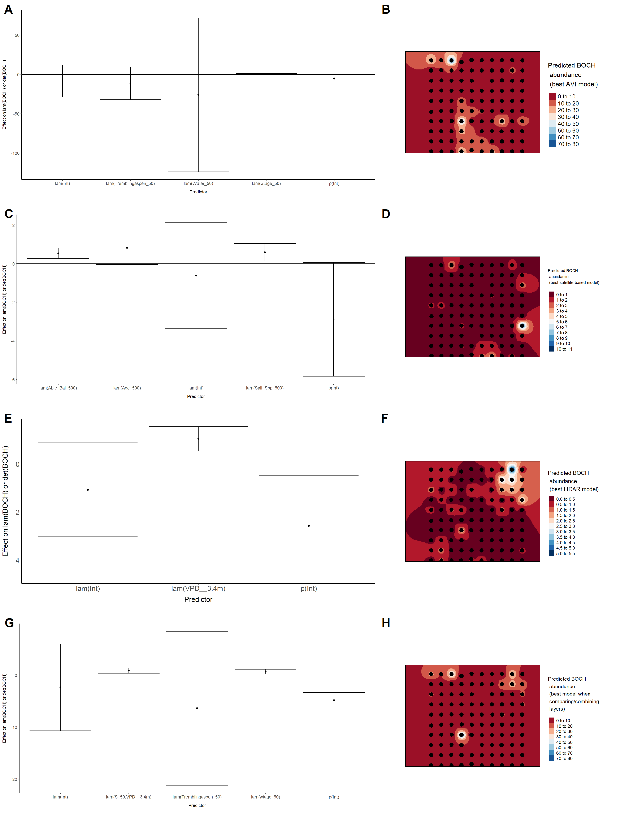

Model coefficients for the A) AVI-based (AIC= 118.63), C) satellite-based (AIC= 126.43), E) lidar-based (AIC= 123.71), and G) composite (AIC= 118.63) *N*-mixture models predicting abundance of Cedar Waxwing *Bombycilla cedrorum*, along with predicted abundances of this species in the Kirby grid from these respective models (B,D,F,H).

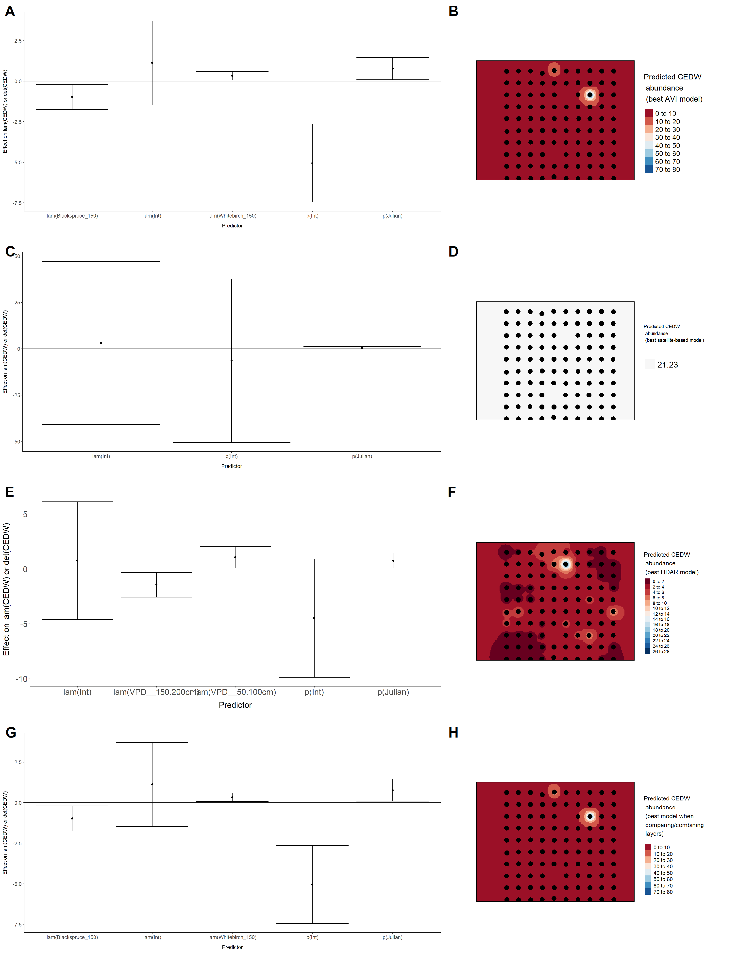

Model coefficients for the A) AVI-based (AIC= 566.71), C) satellite-based (AIC= 573), E) lidar-based (AIC= 550.27), and G) composite (AIC= 550.23) *N*-mixture models predicting abundance of Chipping Sparrow *Spizella passerina*, along with predicted abundances of this species in the Kirby grid from these respective models (B,D,F,H).

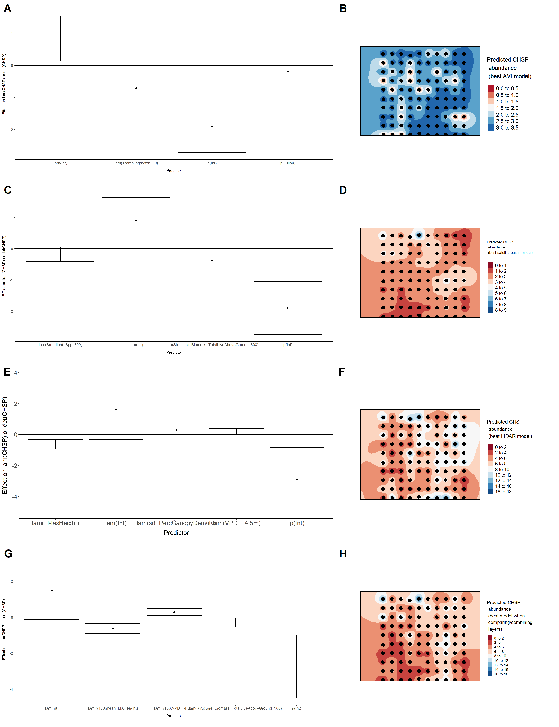

Model coefficients for the A) AVI-based (AIC= 109.5), C) satellite-based (AIC= 120), E) lidar-based (AIC= 113.58), and G) composite (AIC= 108.68) *N*-mixture models predicting abundance of Common Yellowthroat *Geothlypis trichas*, along with predicted abundances of this species in the Kirby grid from these respective models (B,D,F,H).

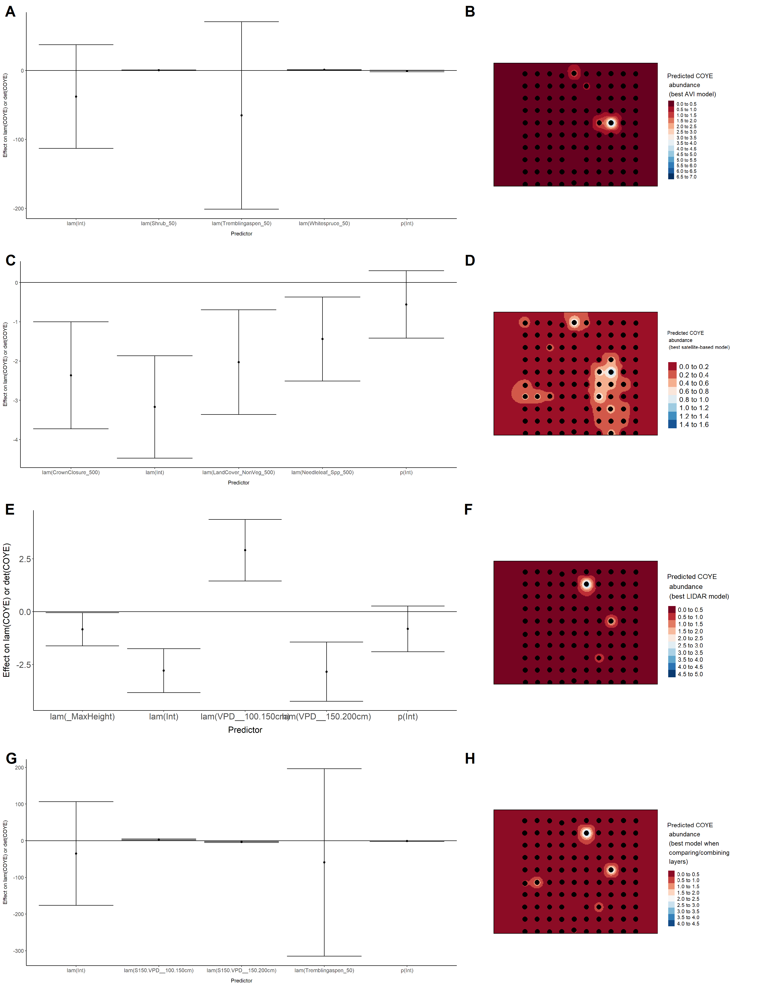

Model coefficients for the A) AVI-based (AIC= 422), C) satellite-based (AIC= 436.37), E) lidar-based (AIC= 422.02), and G) composite (AIC= 418.04) *N*-mixture models predicting abundance of Dark-eyed Junco *Junco hyemalis*, along with predicted abundances of this species in the Kirby grid from these respective models (B,D,F,H).

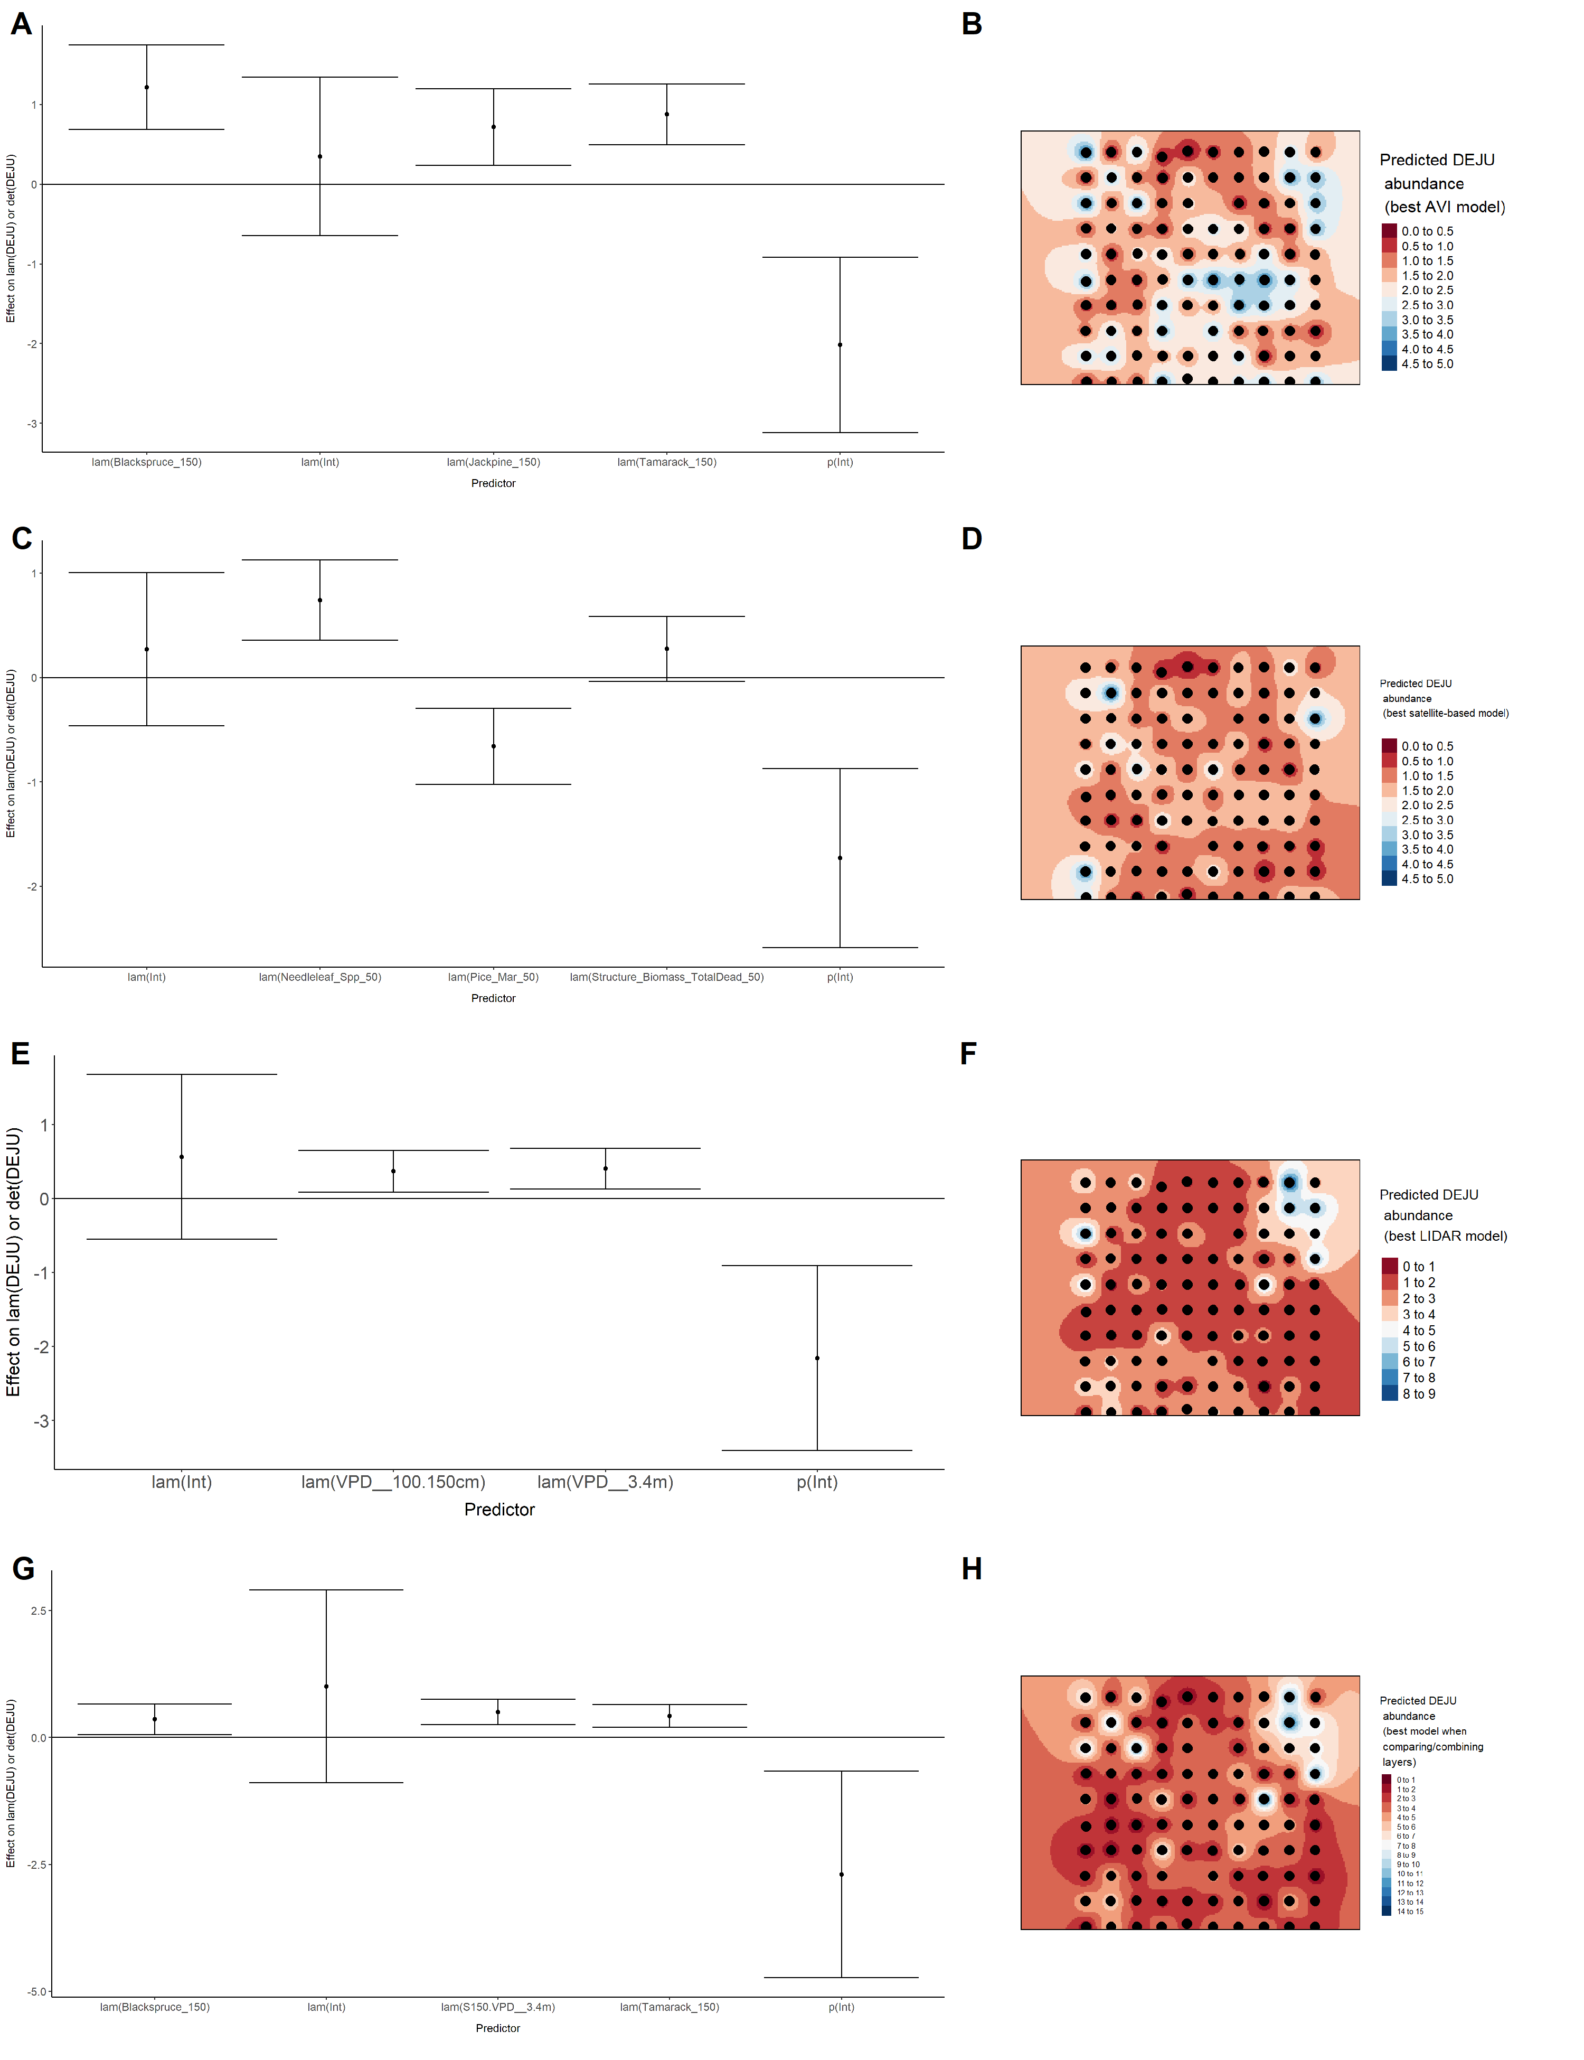

Model coefficients for the A) AVI-based (AIC= 459.33), C) satellite-based (AIC= 460.21), E) lidar-based (AIC= 461.19), and G) composite (AIC= 449.73) *N*-mixture models predicting abundance of Gray Jay *Perisoreus canadensis*, along with predicted abundances of this species in the Kirby grid from these respective models (B,D,F,H).

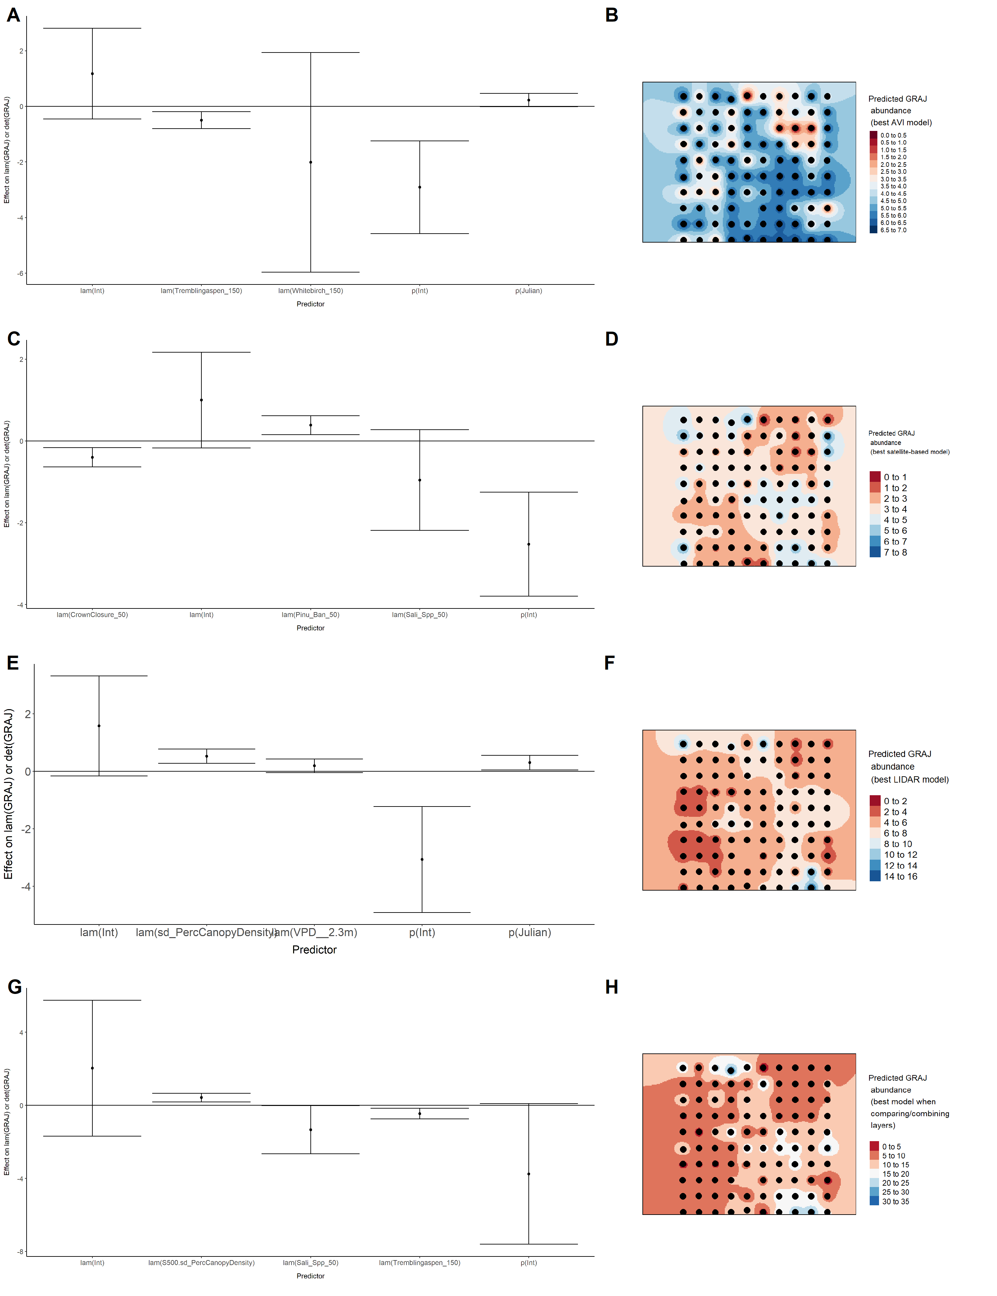

Model coefficients for the A) AVI-based (AIC= 688.17), C) satellite-based (AIC= 688.84), E) lidar-based (AIC= 676.18), and G) composite (AIC= 673.9) *N*-mixture models predicting abundance of Hermit Thrush *Catharus guttatus*, along with predicted abundances of this species in the Kirby grid from these respective models (B,D,F,H).

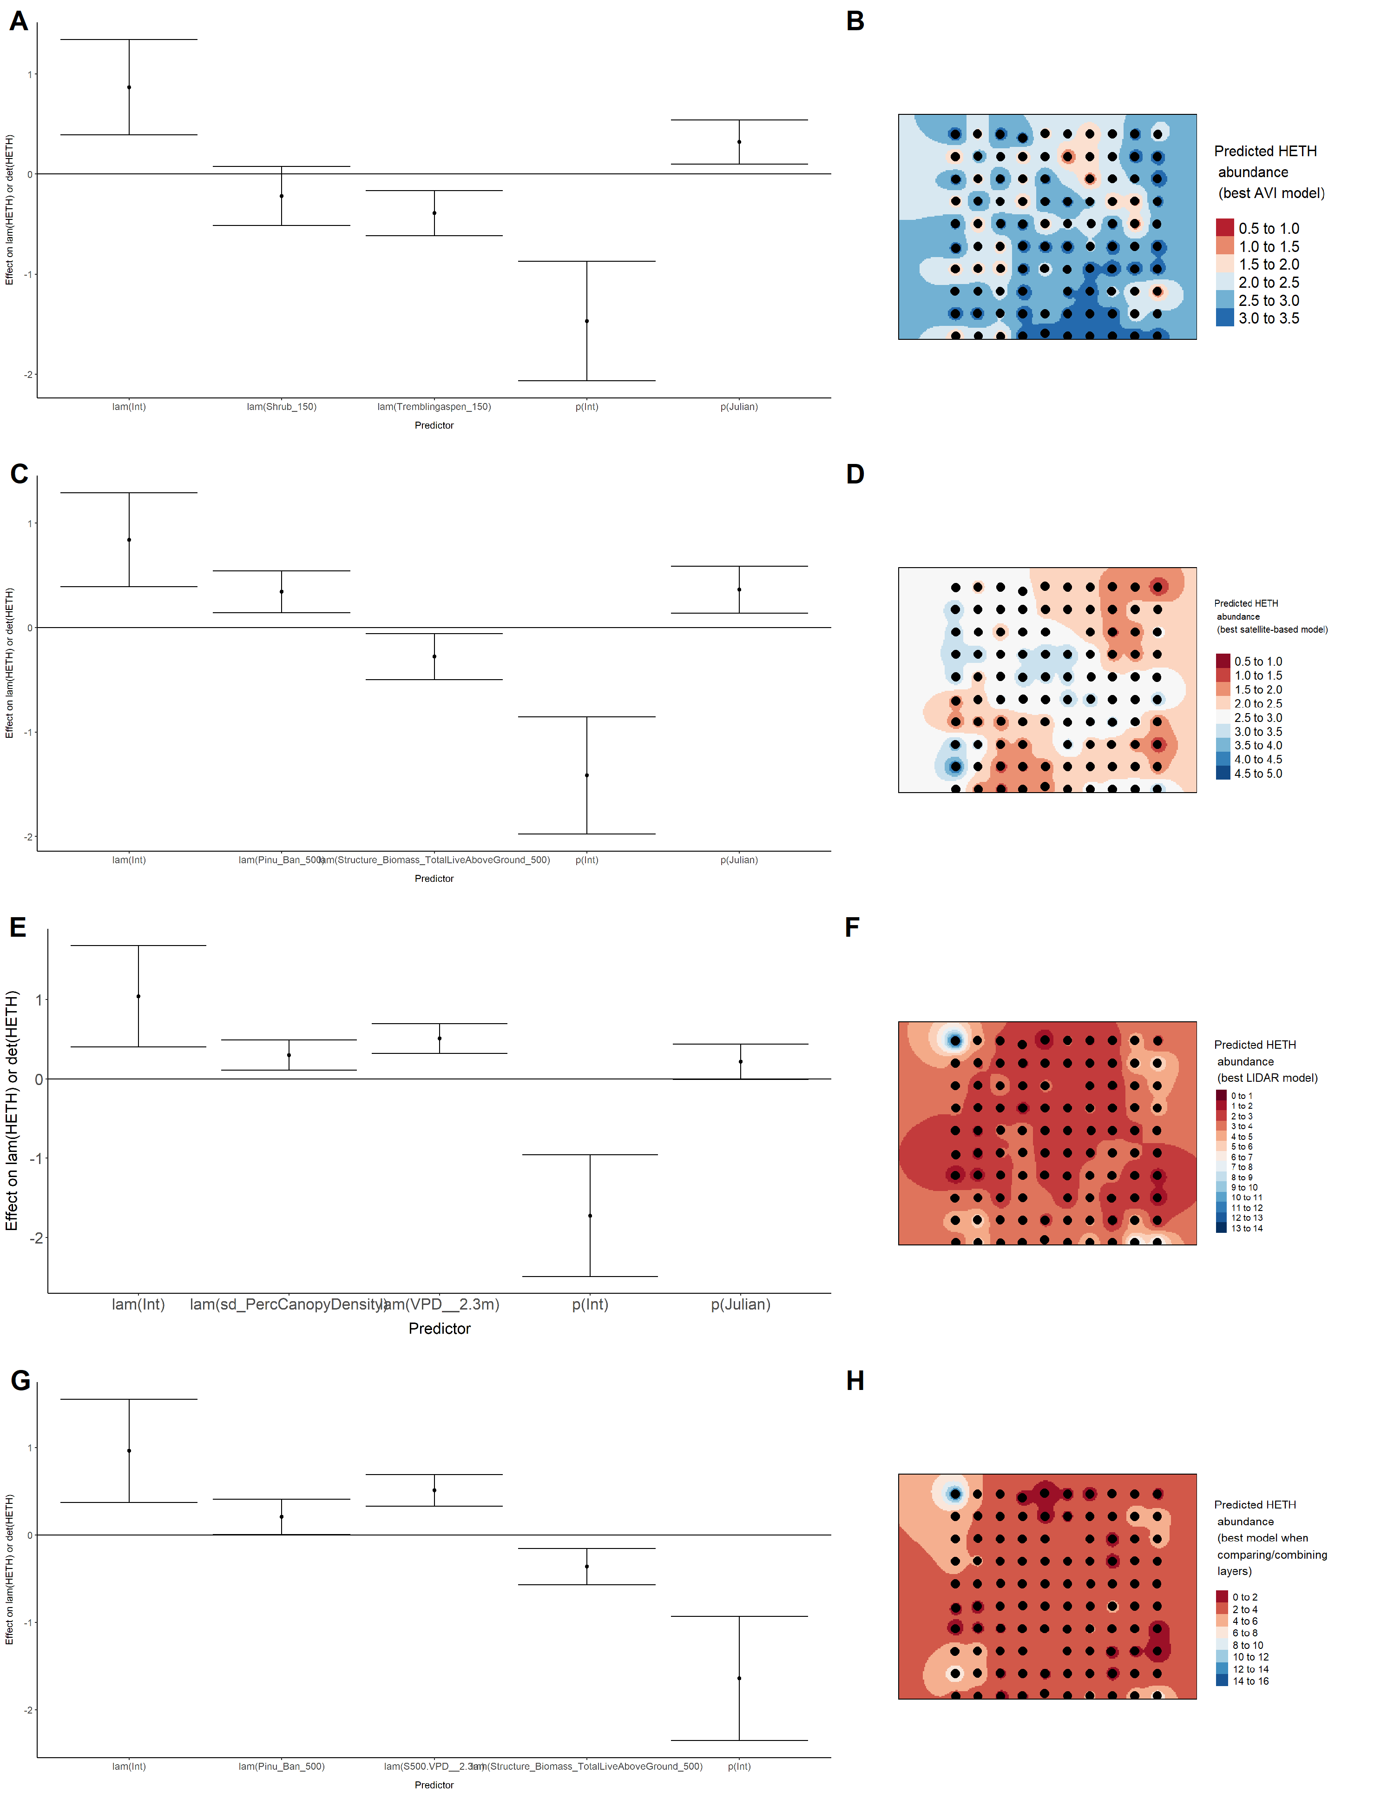

Model coefficients for the A) AVI-based (AIC= 243.47), C) satellite-based (AIC= 238.75), E) lidar-based (AIC= 227.99), and G) composite (AIC= 221.14) *N*-mixture models predicting abundance of Le Conte’s Sparrow *Ammodramus lecontei*, along with predicted abundances of this species in the Kirby grid from these respective models (B,D,F,H).

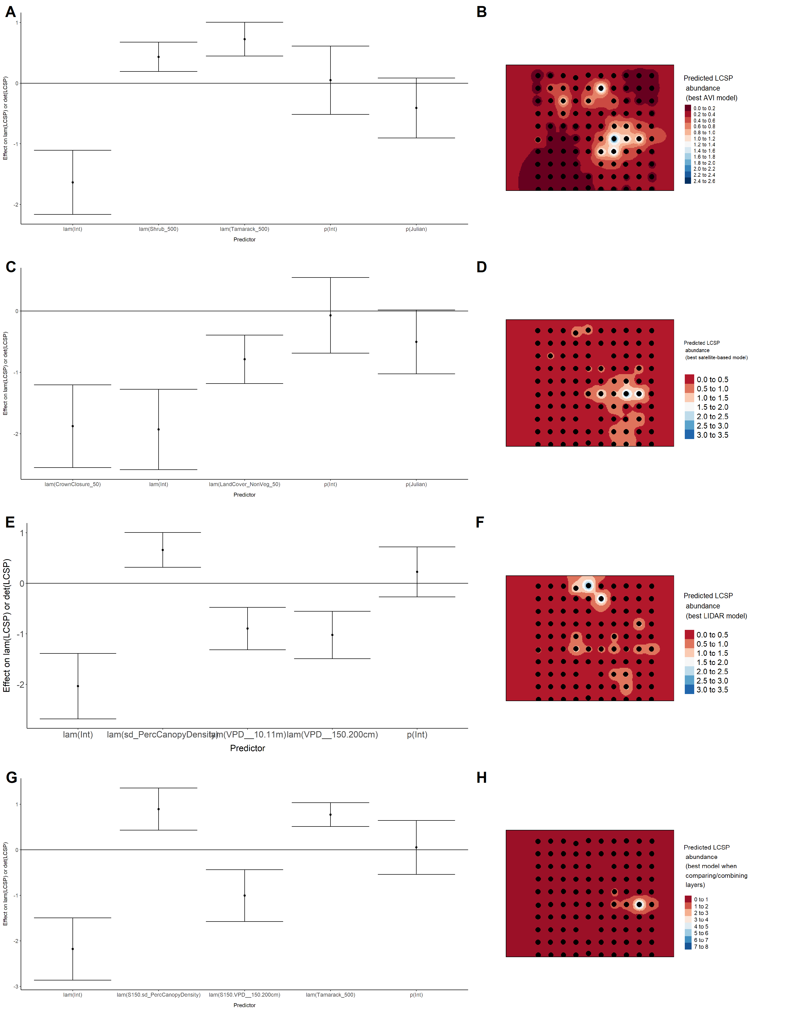

Model coefficients for the A) AVI-based (AIC= 464.25), C) satellite-based (AIC= 465.2), E) lidar-based (AIC= 439.74), and G) composite (AIC= 439.74) *N*-mixture models predicting abundance of Lincoln’s Sparrow *Melospiza lincolnii*, along with predicted abundances of this species in the Kirby grid from these respective models (B,D,F,H).

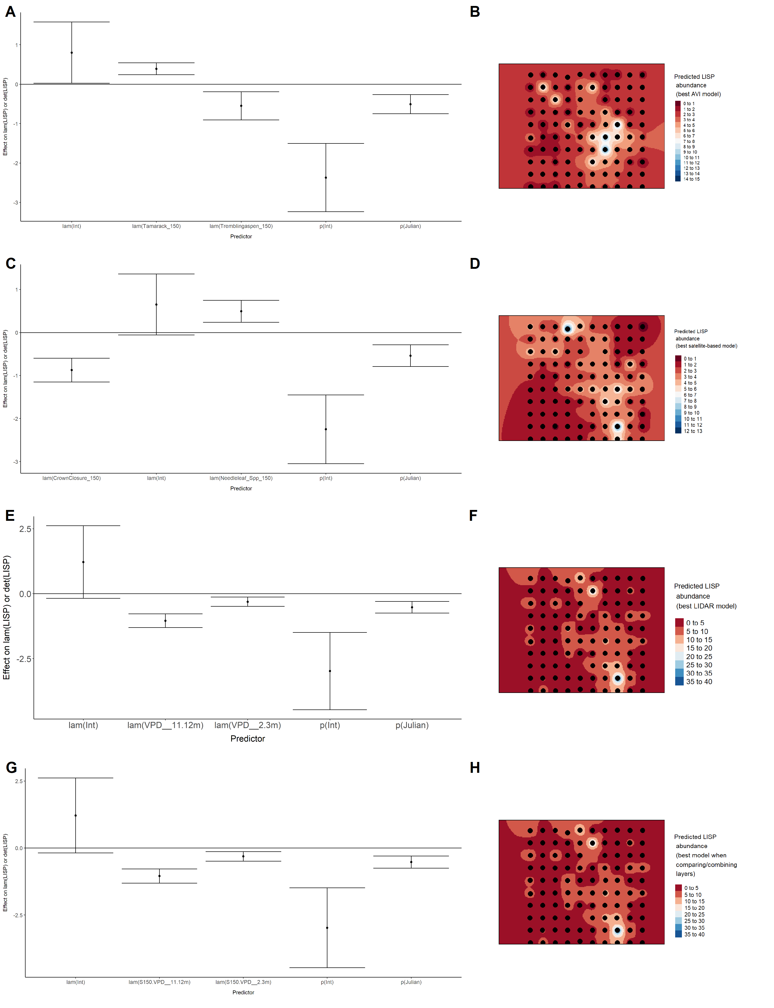

Model coefficients for the A) AVI-based (AIC= 133.74), C) satellite-based (AIC= 130.55), E) lidar-based (AIC= 126.82), and G) composite (AIC= 126.82) *N*-mixture models predicting abundance of Olive-sided Flycatcher *Contopus cooperi*, along with predicted abundances of this species in the Kirby grid from these respective models (B,D,F,H).

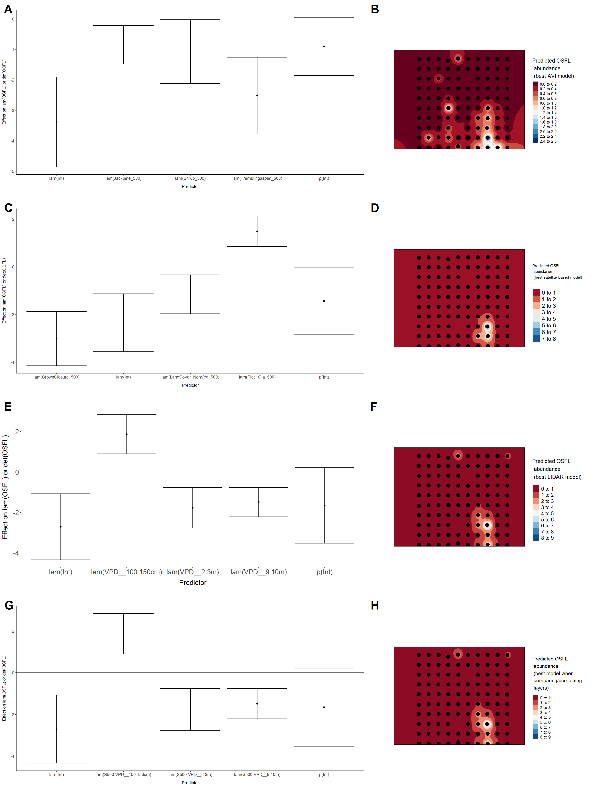

Model coefficients for the A) AVI-based (AIC= 321.36), C) satellite-based (AIC= 334.09), E) lidar-based (AIC= 326.91), and G) composite (AIC= 321.36) *N*-mixture models predicting abundance of Ovenbird *Seiurus aurocapillus*, along with predicted abundances of this species in the Kirby grid from these respective models (B,D,F,H).

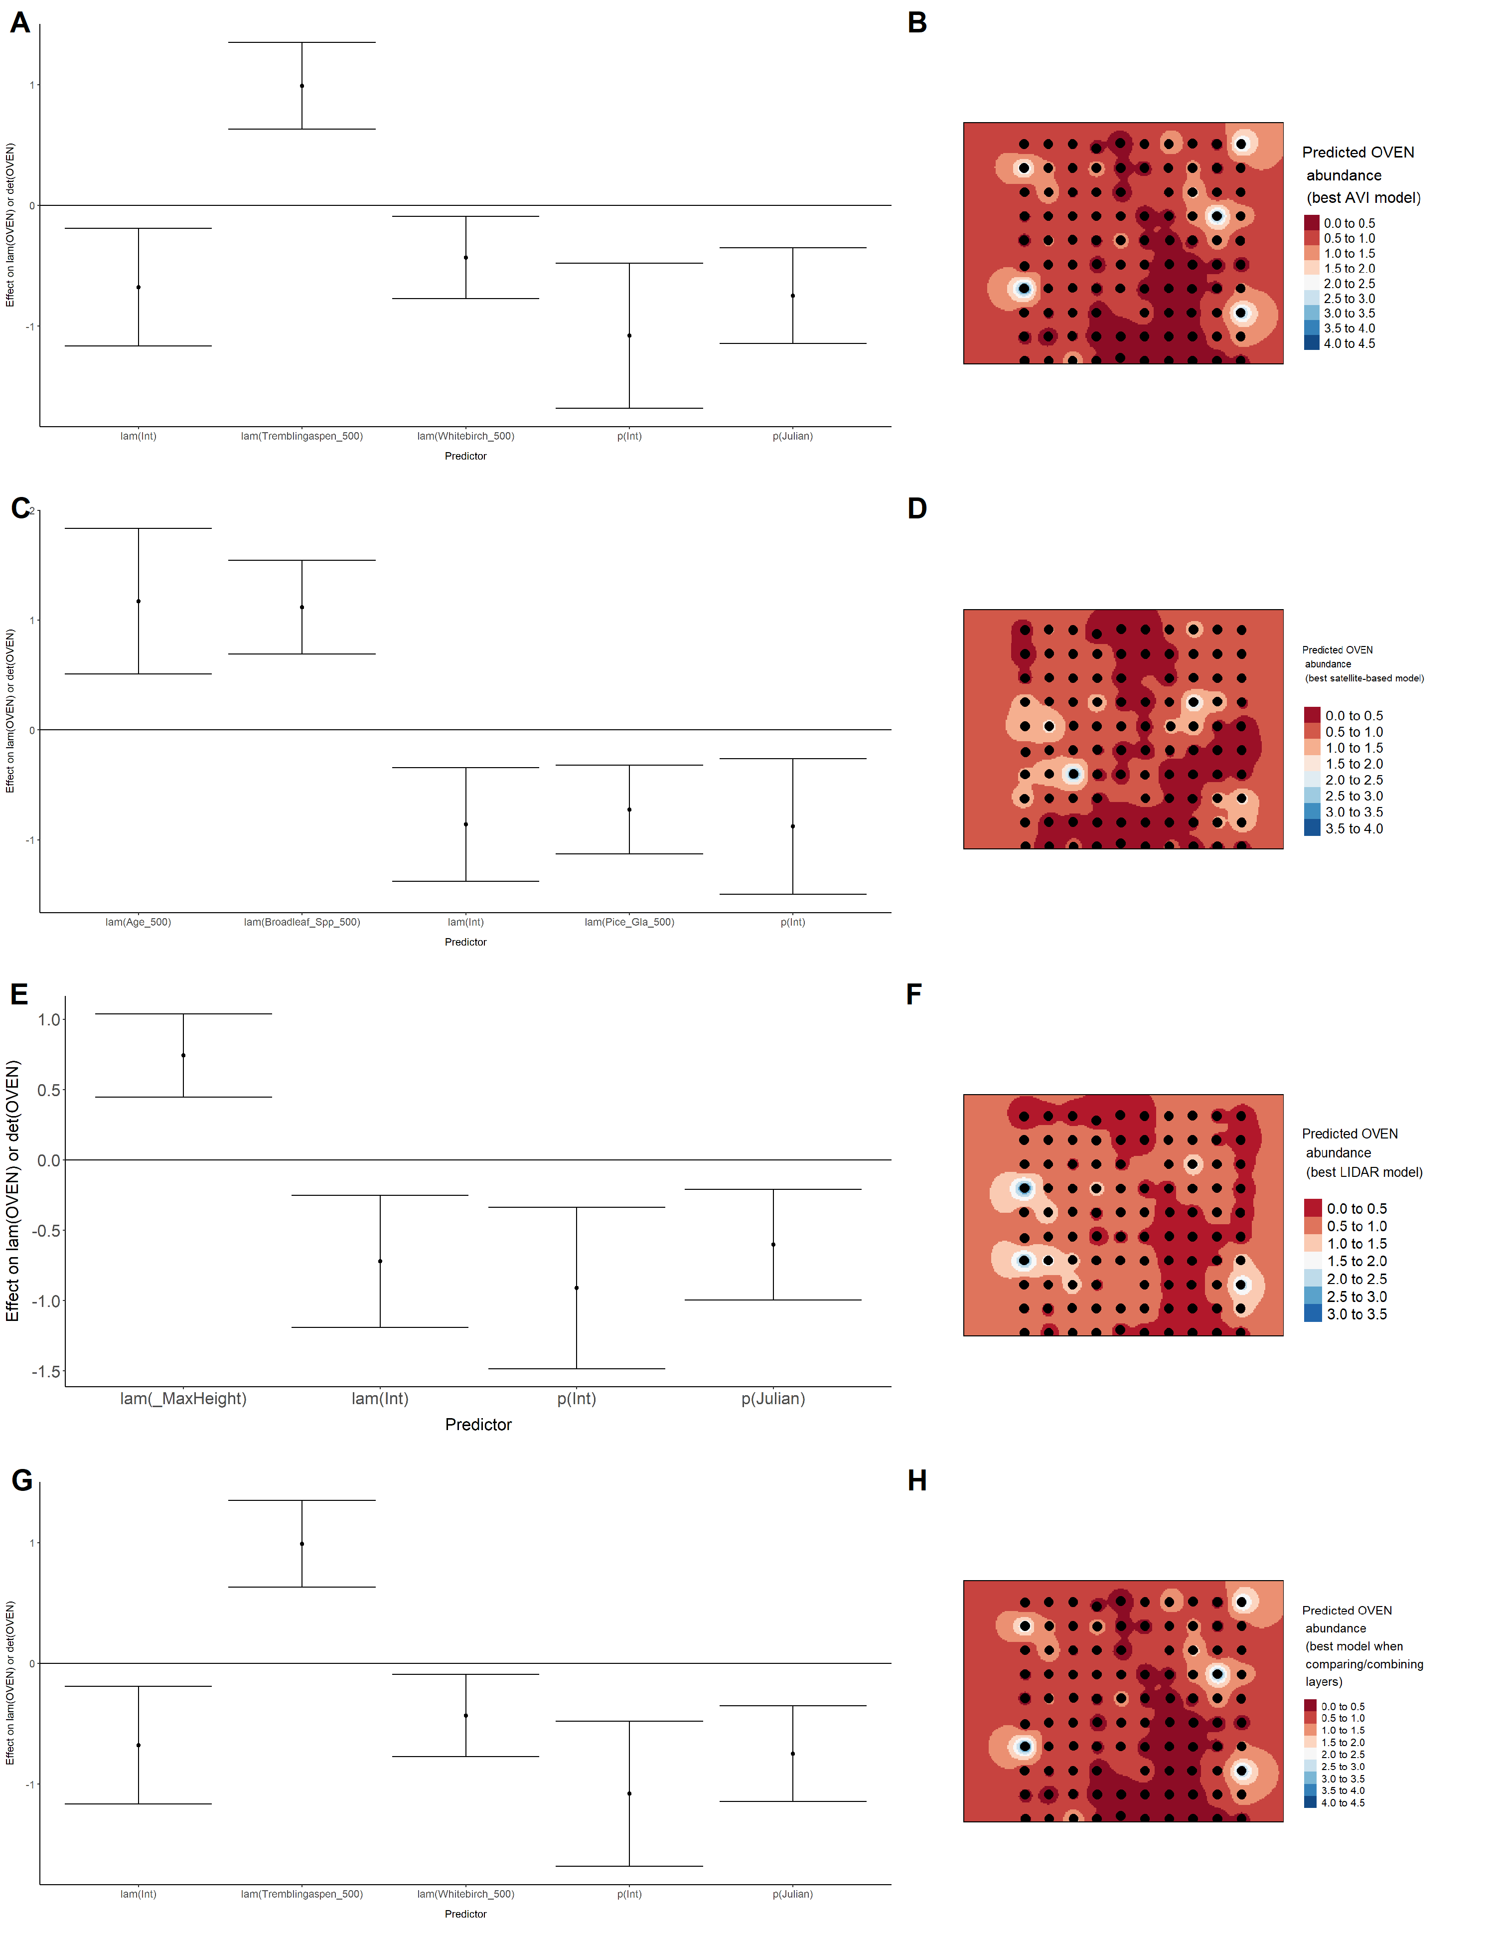

Model coefficients for the A) AVI-based (AIC= 153.98), C) satellite-based (AIC= 164.33), E) lidar-based (AIC= 156.91), and G) composite (AIC= 151.97) *N*-mixture models predicting abundance of Palm Warbler *Setophaga palmarum*, along with predicted abundances of this species in the Kirby grid from these respective models (B,D,F,H).

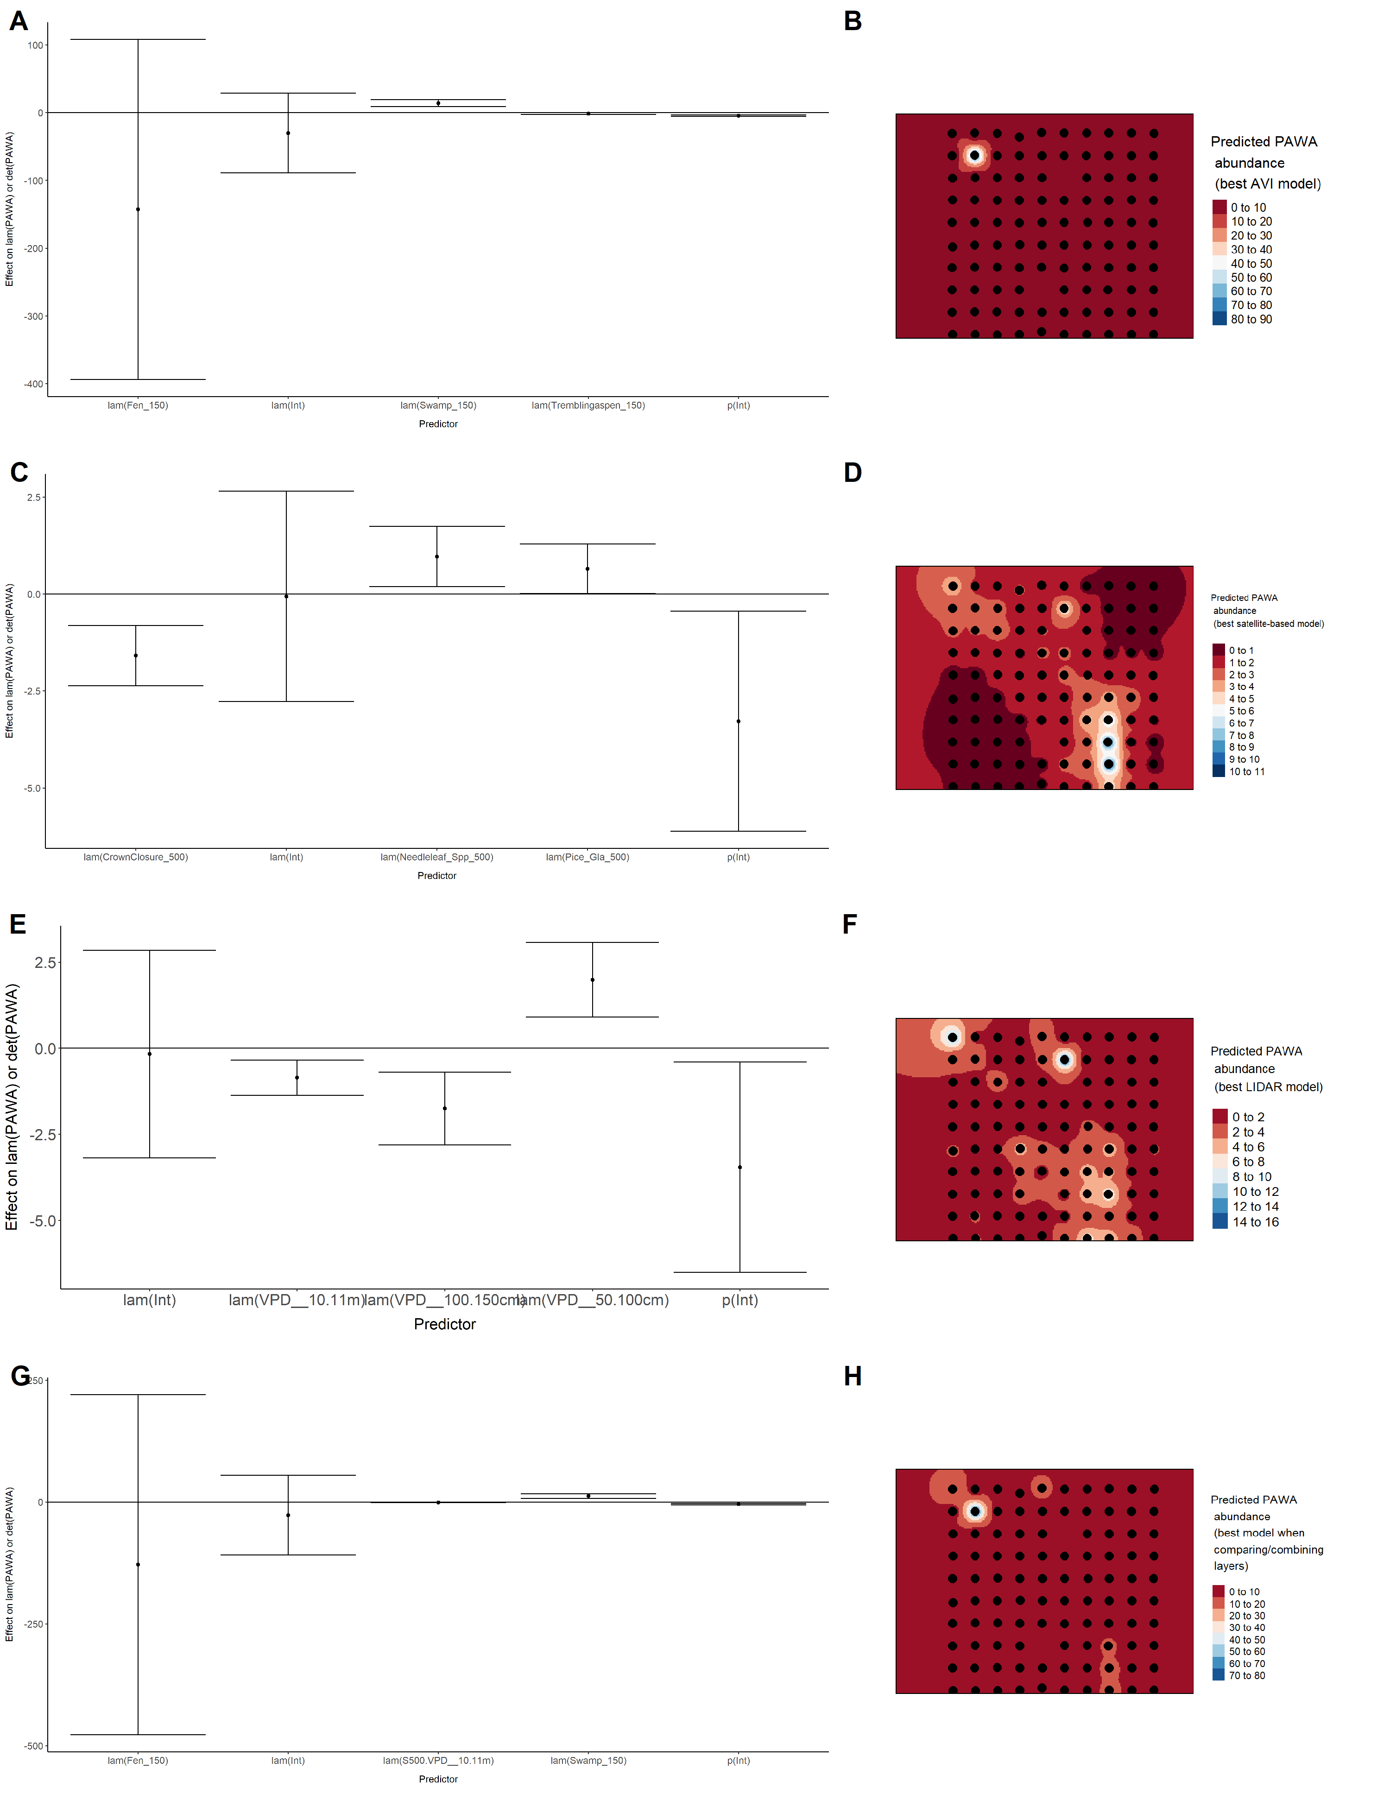

Model coefficients for the A) AVI-based (AIC= 265.41), C) satellite-based (AIC= 280.83), E) lidar-based (AIC= 286.33), and G) composite (AIC= 263.87) *N*-mixture models predicting abundance of Red-eyed Vireo *Vireo olivaceus*, along with predicted abundances of this species in the Kirby grid from these respective models (B,D,F,H).

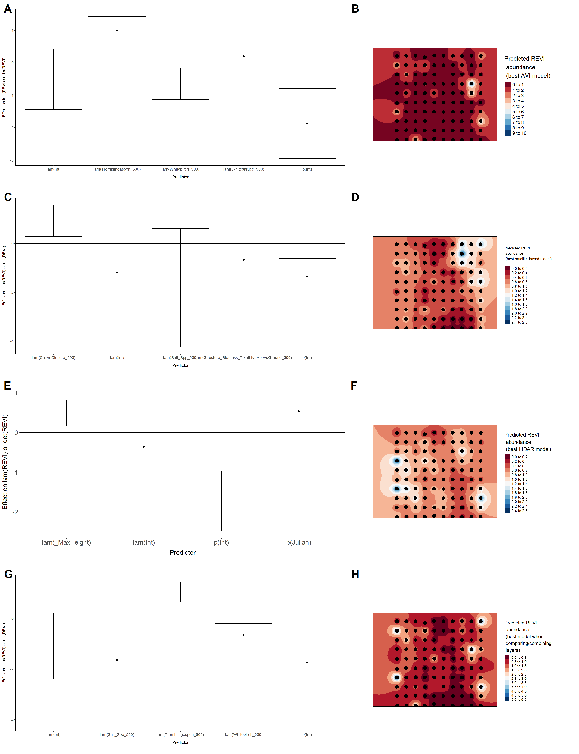

Model coefficients for the A) AVI-based (AIC= 361.85), C) satellite-based (AIC= 357.62), E) lidar-based (AIC= 355.53), and G) composite (AIC= 353.02) *N*-mixture models predicting abundance of Ruby-crowned Kinglet *Regulus calendula*, along with predicted abundances of this species in the Kirby grid from these respective models (B,D,F,H).

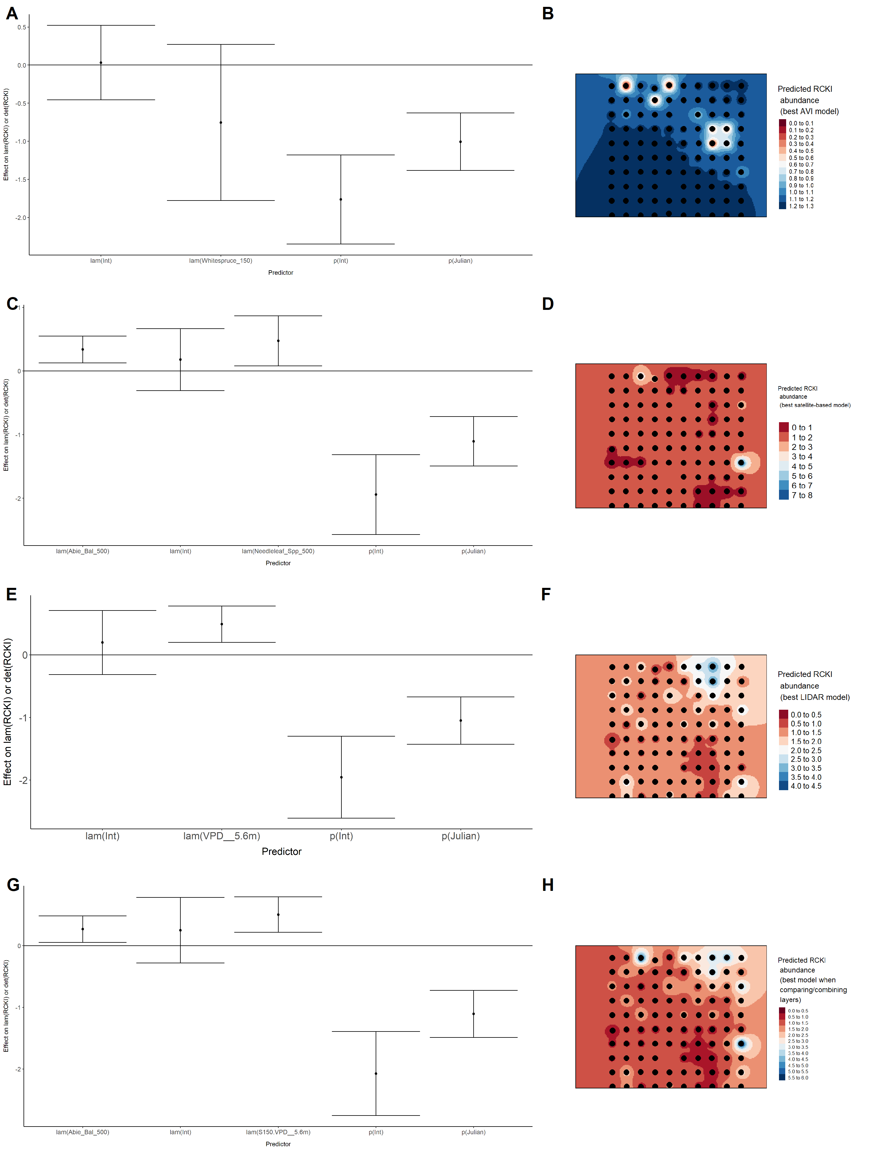

Model coefficients for the A) AVI-based (AIC= 664.61), C) satellite-based (AIC= 657.54), E) lidar-based (AIC= 660.96), and G) composite (AIC= 660.45) *N*-mixture models predicting abundance of Swainson’s Thrush *Catharus ustulatus*, along with predicted abundances of this species in the Kirby grid from these respective models (B,D,F,H).

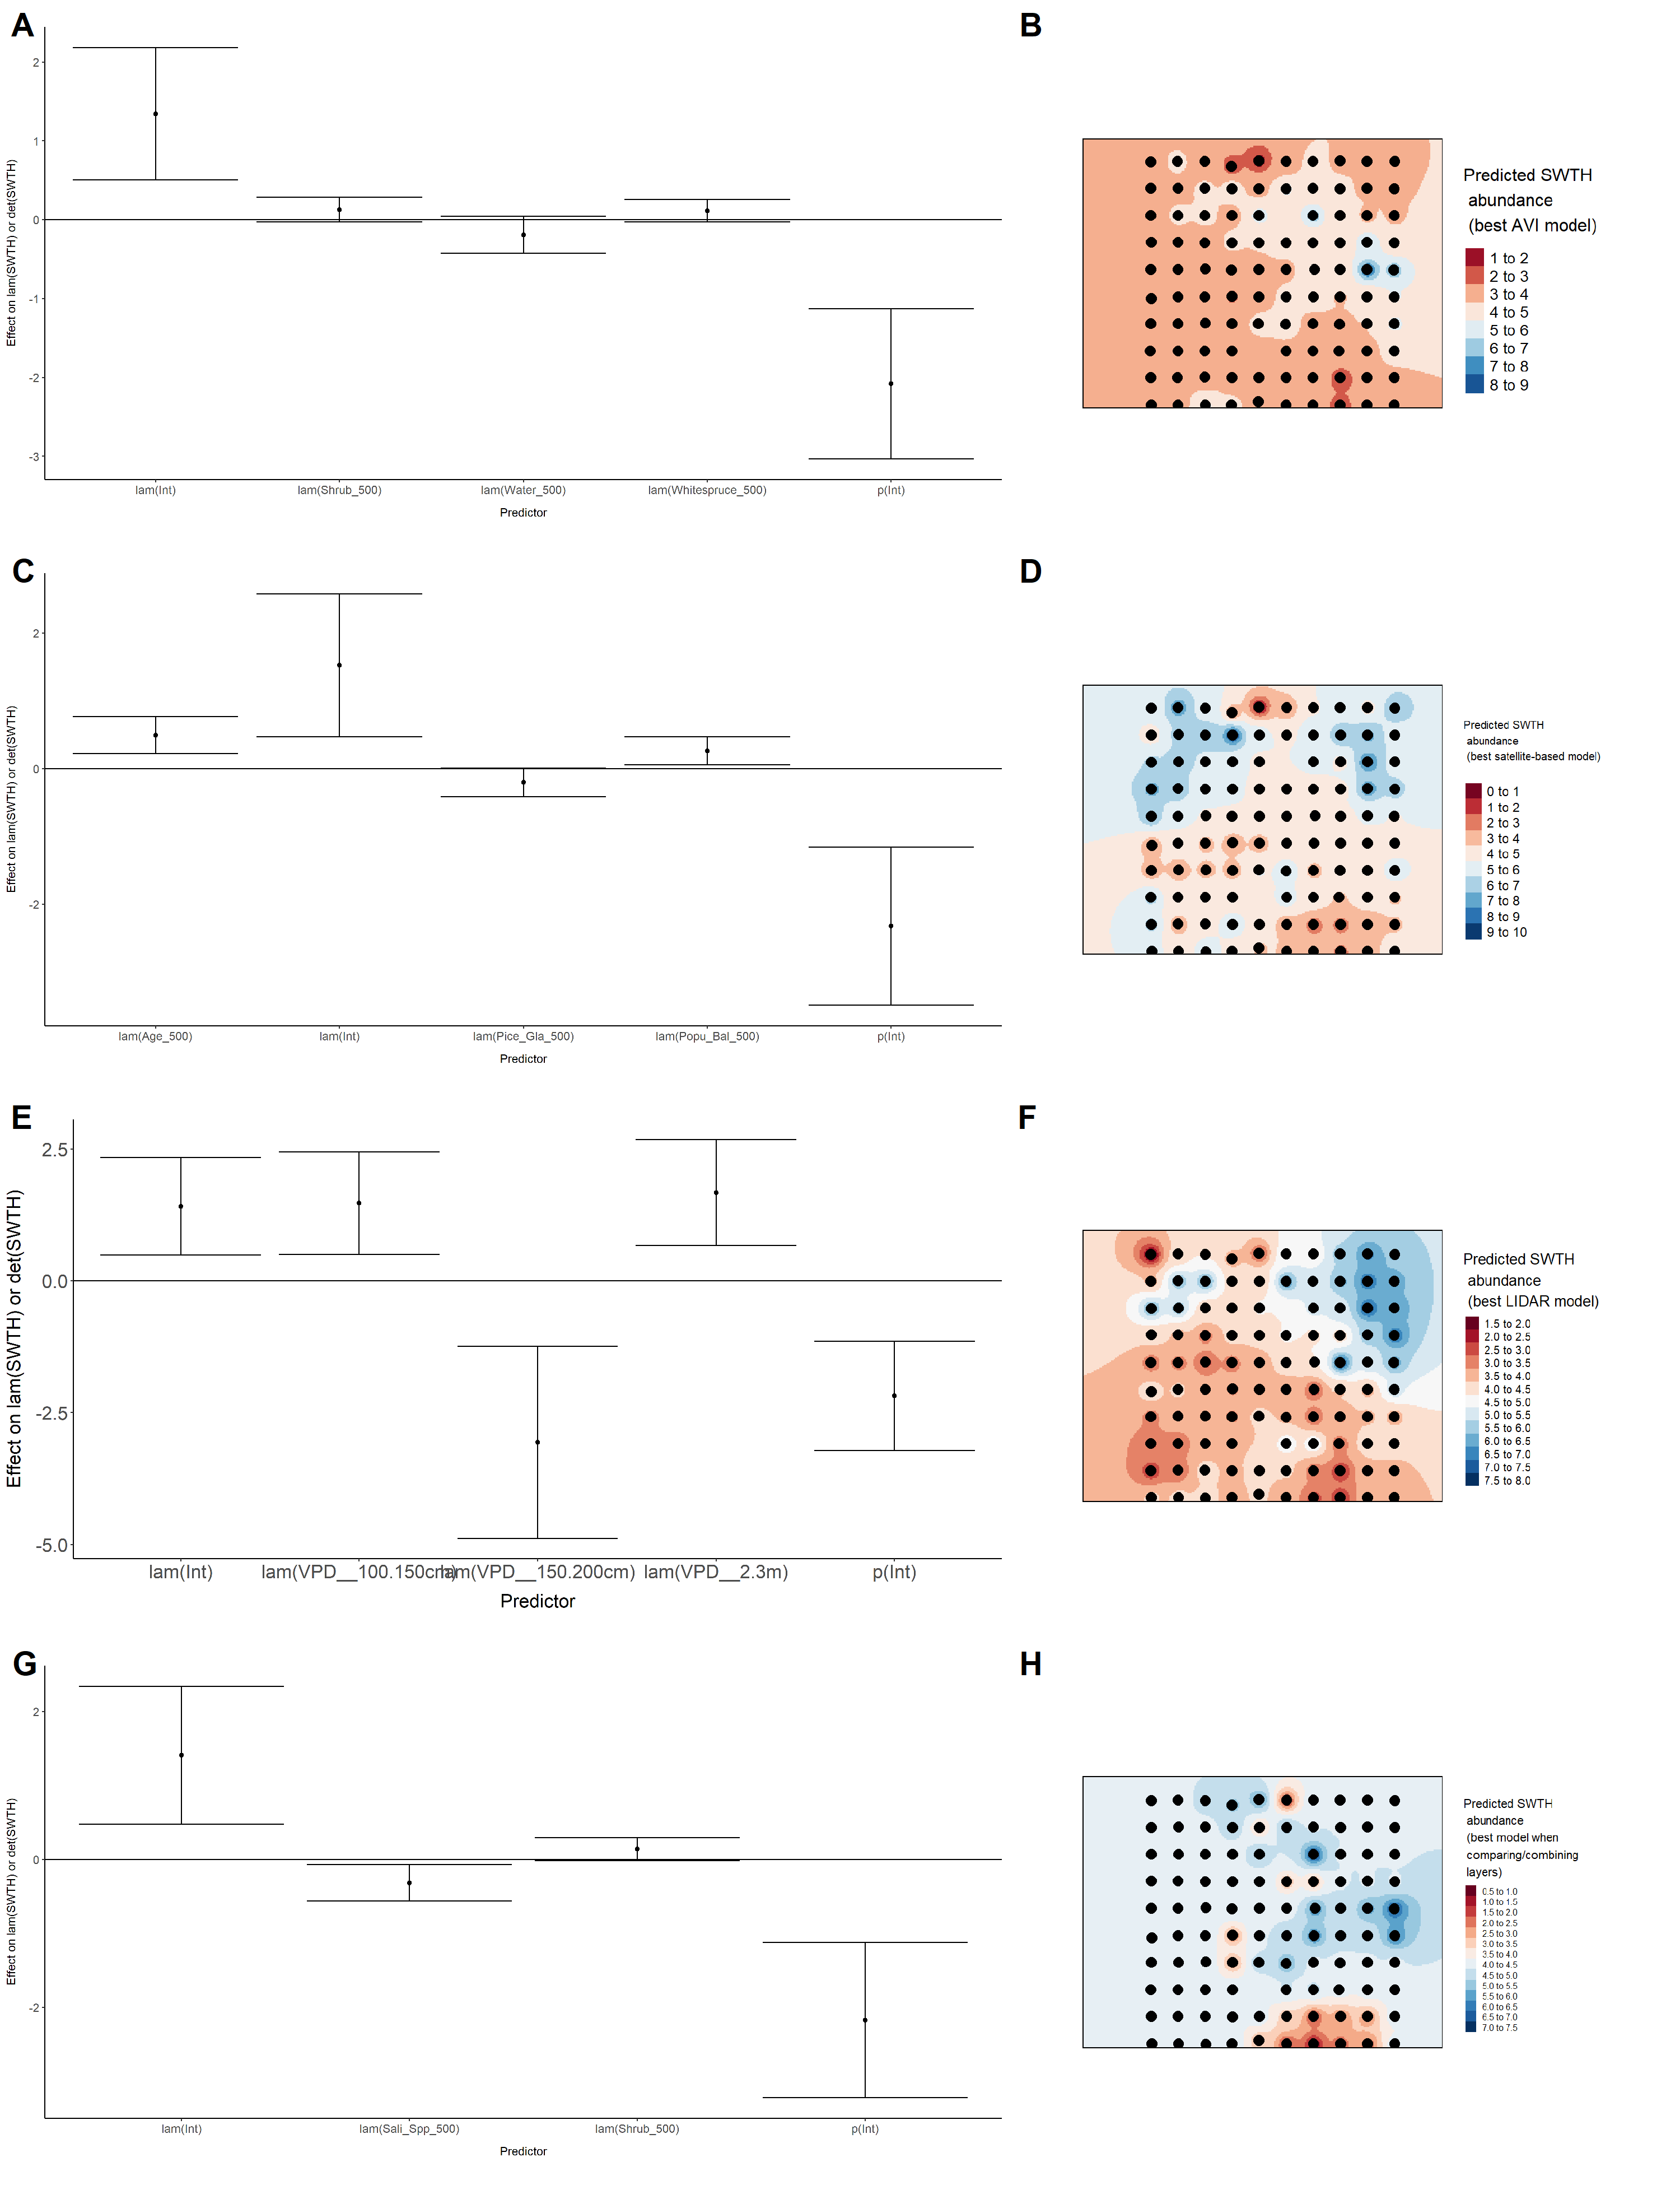

Model coefficients for the A) AVI-based (AIC= 127.82), C) satellite-based (AIC= 139.33), E) lidar-based (AIC= 138.15), and G) composite (AIC= 127.2) *N*-mixture models predicting abundance of Swamp Sparrow *Melospiza georgiana*, along with predicted abundances of this species in the Kirby grid from these respective models (B,D,F,H).

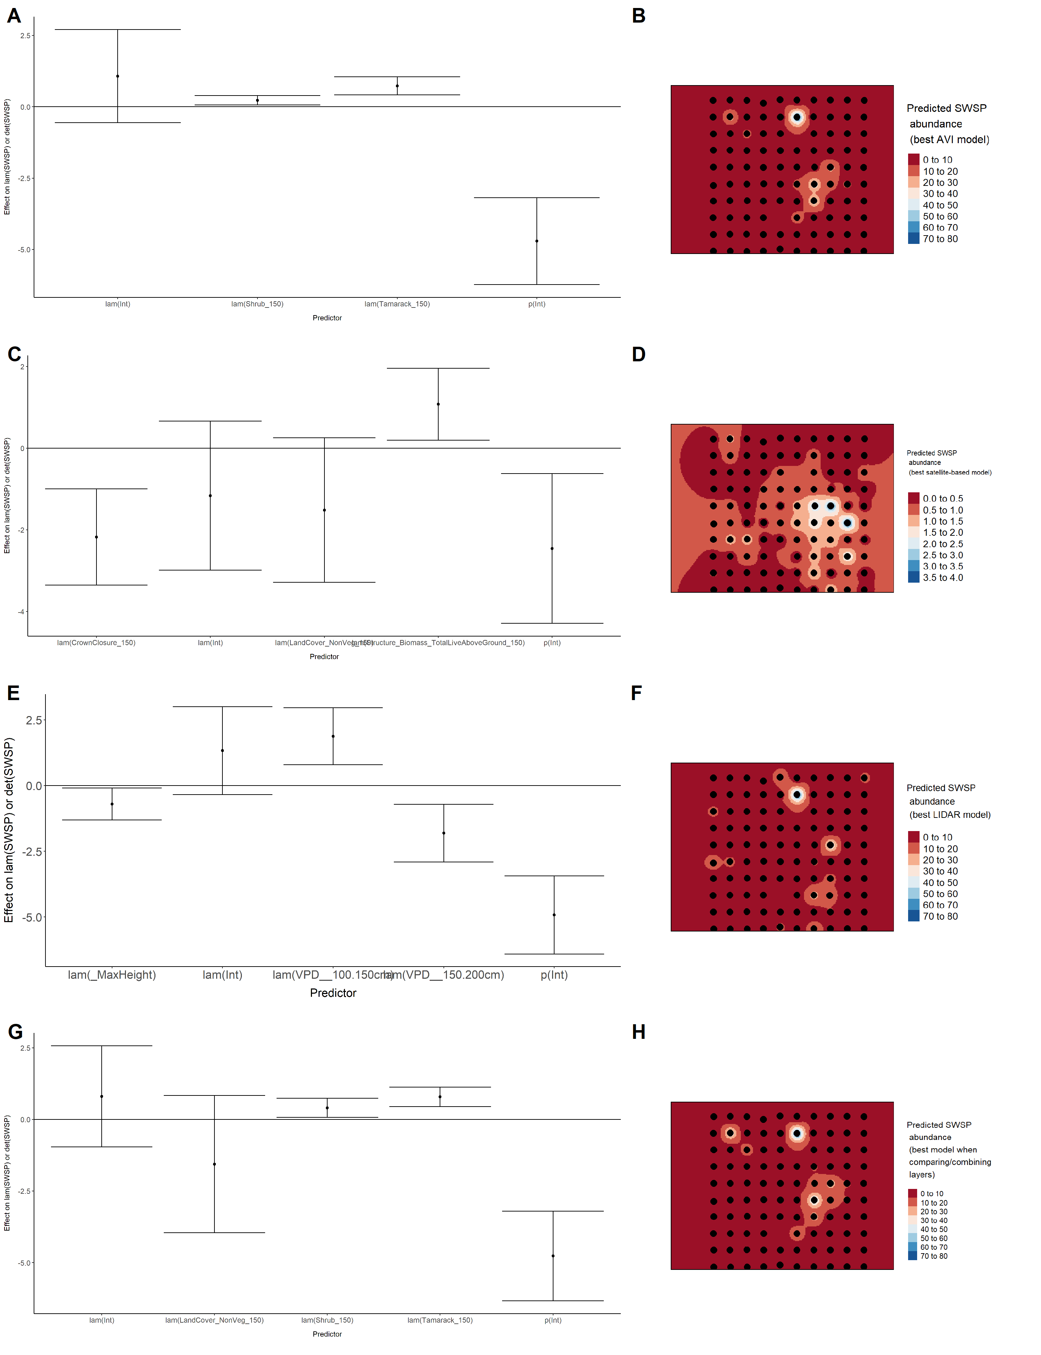

Model coefficients for the A) AVI-based (AIC= 317.57), C) satellite-based (AIC= 322.11), E) lidar-based (AIC= 322.38), and G) composite (AIC= 317.02) *N*-mixture models predicting abundance of Tennessee Warbler *Leiothlypis peregrina*, along with predicted abundances of this species in the Kirby grid from these respective models (B,D,F,H).

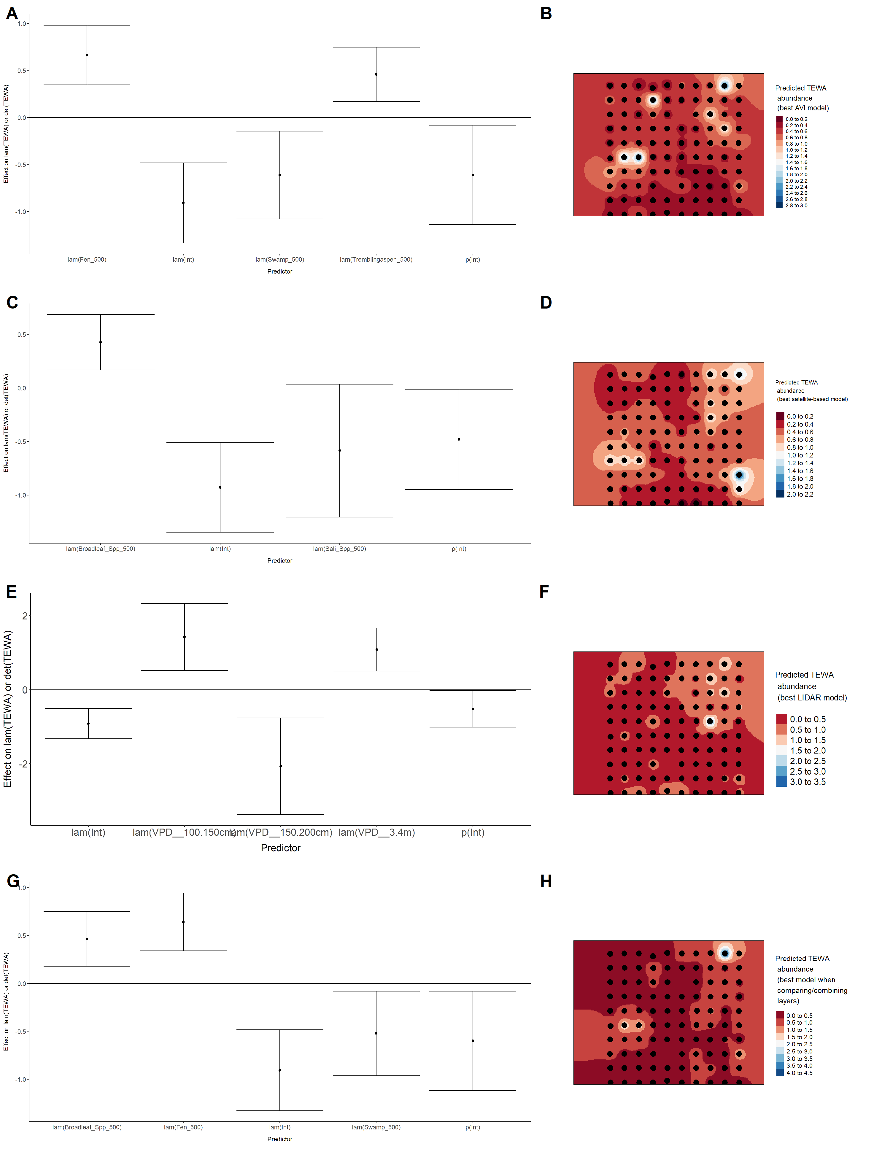

Model coefficients for the A) AVI-based (AIC= 260.39), C) satellite-based (AIC= 269.42), E) lidar-based (AIC= 259.32), and G) composite (AIC= 259.32) *N*-mixture models predicting abundance of Winter Wren *Troglodytes hiemalis*, along with predicted abundances of this species in the Kirby grid from these respective models (B,D,F,H).

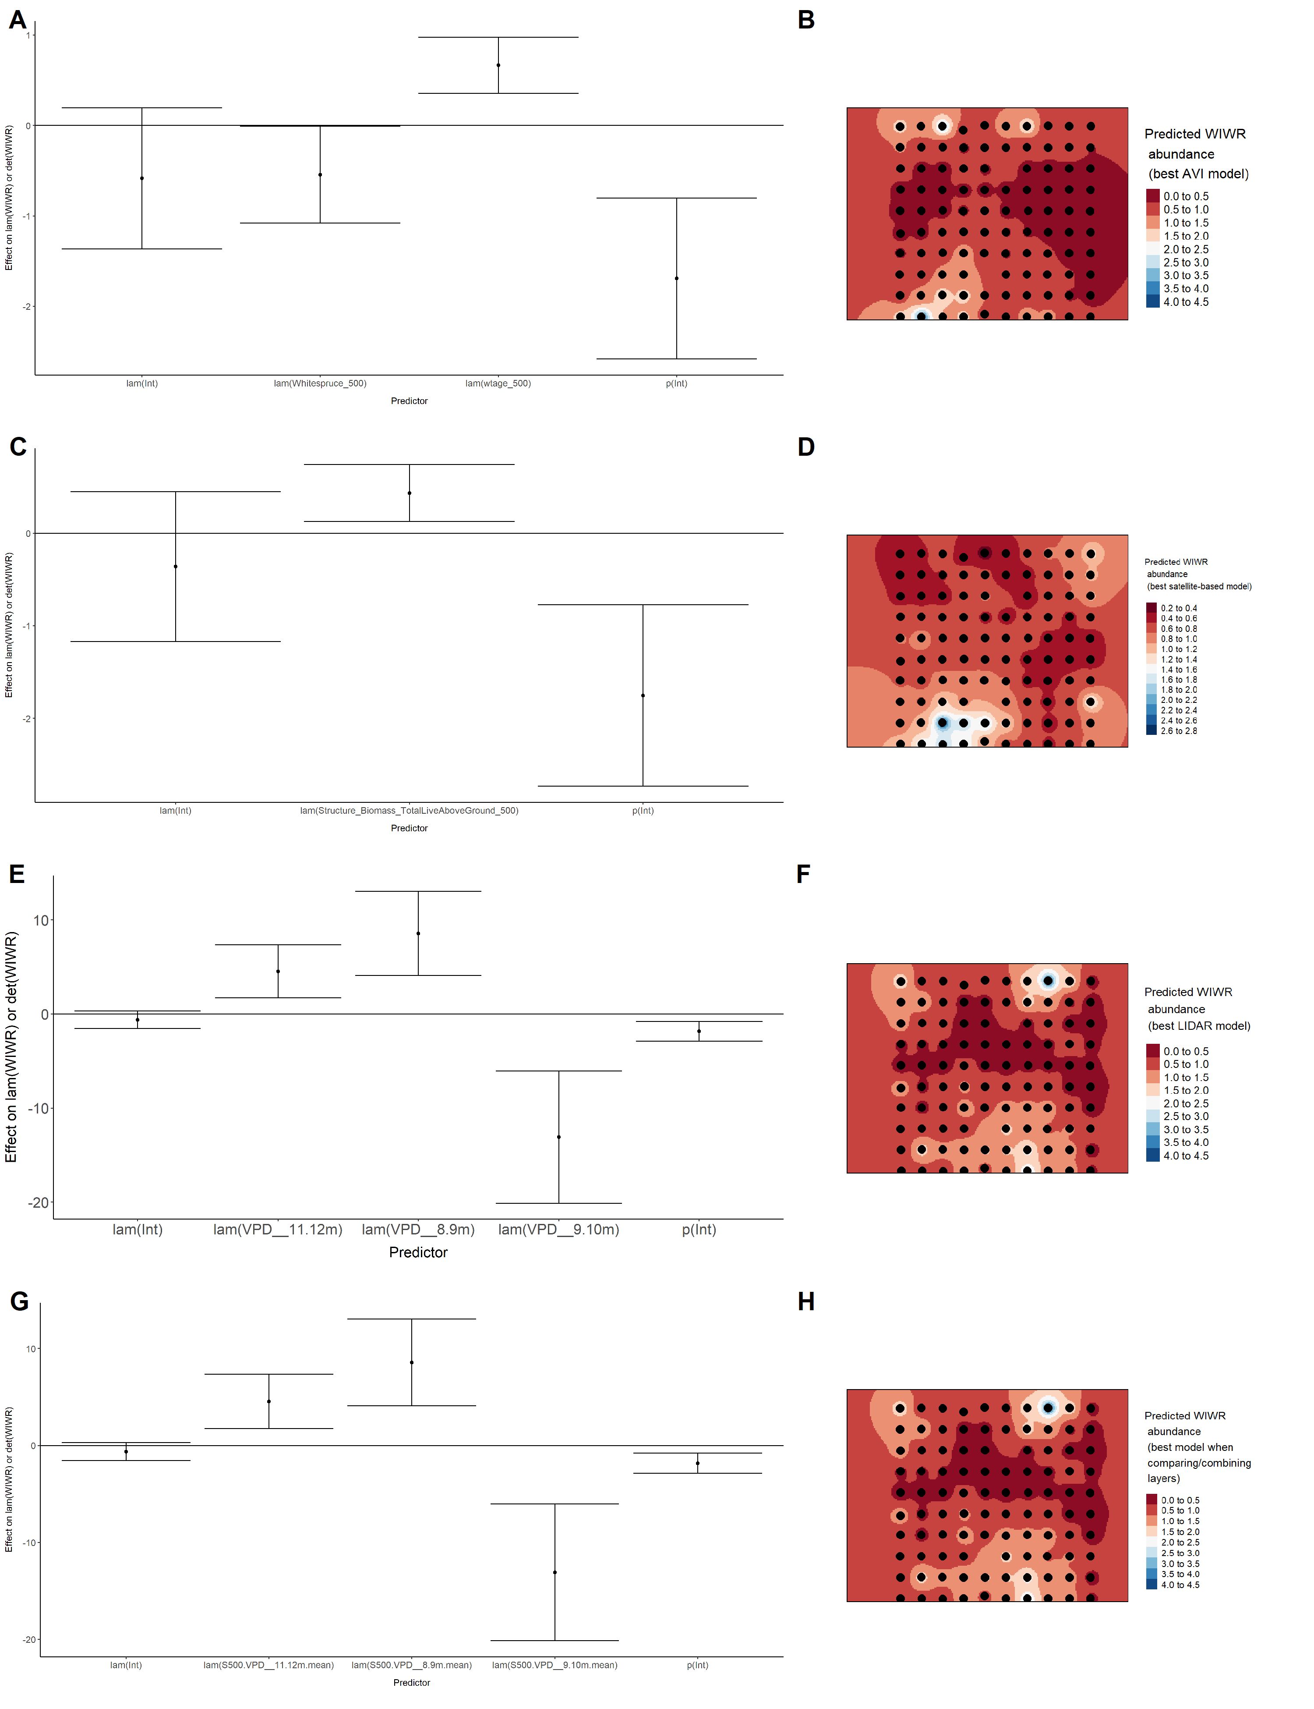

Model coefficients for the A) AVI-based (AIC= 318.9), C) satellite-based (AIC= 312.28), E) lidar-based (AIC= 331.48), and G) composite (AIC= 307.17) *N*-mixture models predicting abundance of White-throated Sparrow *Zonotrichia albicollis*, along with predicted abundances of this species in the Kirby grid from these respective models (B,D,F,H).

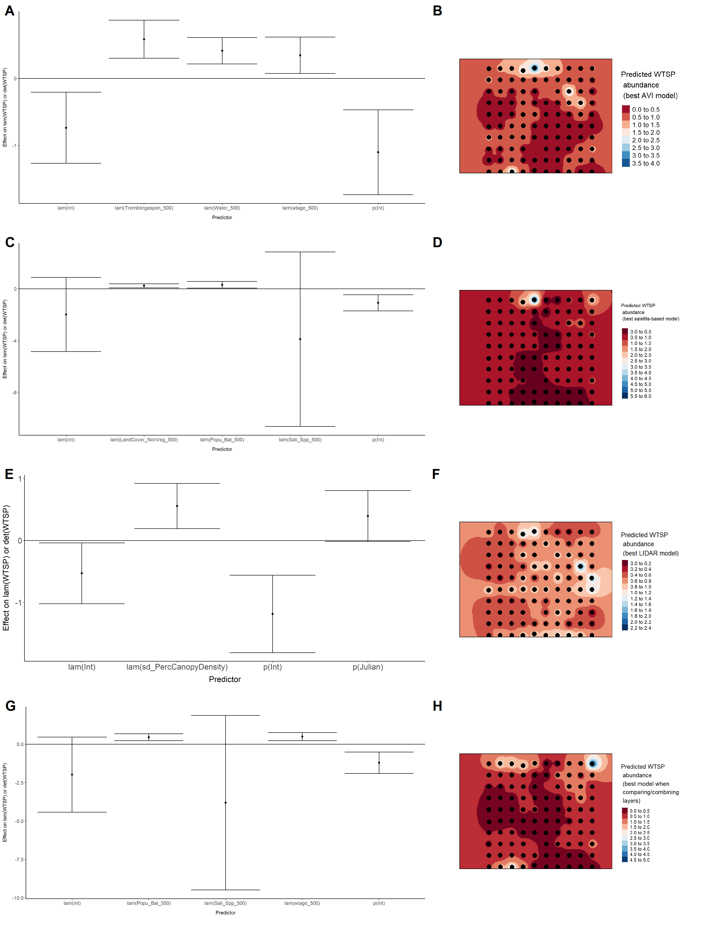

Model coefficients for the A) AVI-based (AIC= 674.11), C) satellite-based (AIC= 679.02), E) lidar-based (AIC= 678.17), and G) composite (AIC= 671.32) *N*-mixture models predicting abundance of Yellow-rumped Warbler *Setophaga coronata*, along with predicted abundances of this species in the Kirby grid from these respective models (B,D,F,H).

